TriggerBox (Transmitter) |  | Parameter | Typ. | Unit
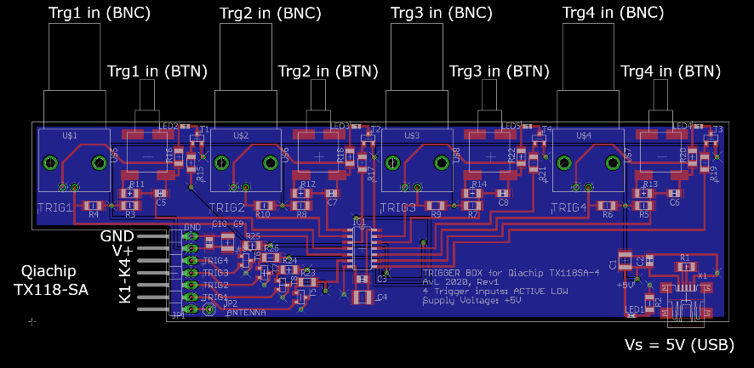  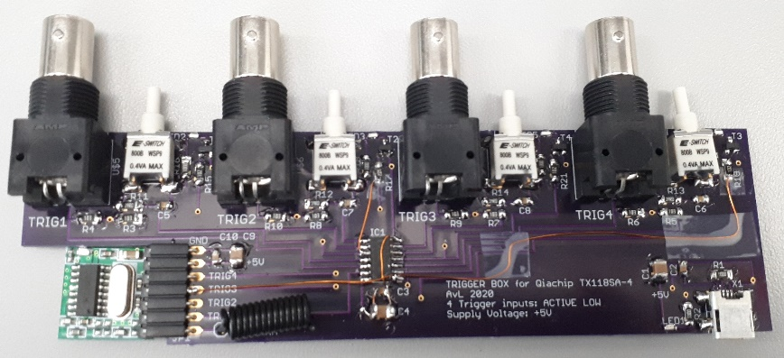  Based on Qiachip TX118SA-4(433MHz) |  | V_{supply} (mini USB) | 5V | V
 |  | TTL input logic level  (BNC trigger in) | < 0.8 (low)  > 2 (high) | V
 |  | # Tx channels (K1-K4) | 4
 |  | trigger transmission: | Active Low
 |  | power on LED | 1 x green
 |  | Tx input active LED | 4 x blue
 |  | Tx trigger LED | 1 x red
 |  | 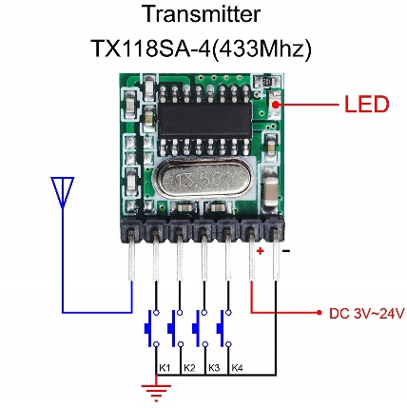
Wireless Receiver |  | Parameter | Typ.
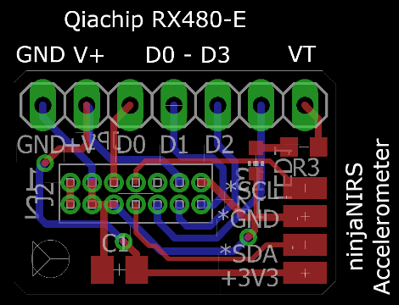 Note: populate ANTenna!  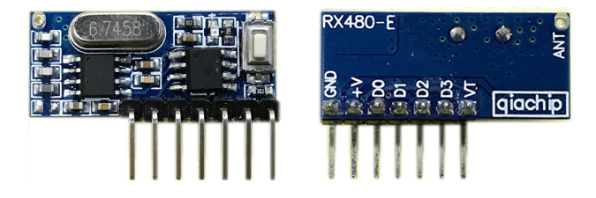  Based on Qiachip RX480-E |  | V_{supply} | 3.3 – 5 | V
 |  | logic trigger level  (Dx out) | 0 - V_{supply} | V
 |  | # Rx channels (D0-D3) | 4
 |  | Receive sensitivity | -108 | dB
 |  | Frequency band | 433±.2 | MHz
 |  | Trigger reception (toggling): | Rising/falling edge
 |  | Rx trigger LED | 1 x red
 |  | Quiescent current: | ≤ 5 | mA
 |  | Output current: | 10 | mA
 |  | Delay / Jitter  Tx edge -> Rx edge | 76.9 ± 18.9 | ms
 |  | Range  (Qiachip datasheet): | >15 | m
 |  | Range  (tested, open field) | >25 | m
Wireless trigger transceiver extension for the ninjaNIRS, based on on Qiachip TX1182SA-4 and RX480-E. Supports pairing between Rx/Tx components and 4 digital trigger channels that can be individually controlled via schmitt-triggered BNC (TTL level) input or debounced button press. Average delay between trigger transmission and reception is <80ms, jitter (std) 20ms. Range up to 25m (open field).

Pairing Instructions for Receiver (supplier notes):
- Delete existing data: Press learning button 8 times. Response: LED flashes 7 times.
- Learning remote code: press learning key once, twice or three times (see below).
LED turns on: learning mode is active. Press any button of the remote control.
LED indicator flashes three times: learning successfully completed.
- Test: after the above operation the receiver board can be controlled by the remote control.
Functions:
- Press once: Inching mode (Momentary Mode)
- Press twice: self-Lock Mode (Toggle-Mode of the 4 Channels)
- Press three times: interlocked mode (selected channel active and be cleared, if another channel becomes active)
Demonstration of pairing (video):
https://www.youtube.com/watch?time_continue=2&v=kr3RJoQmPvw

